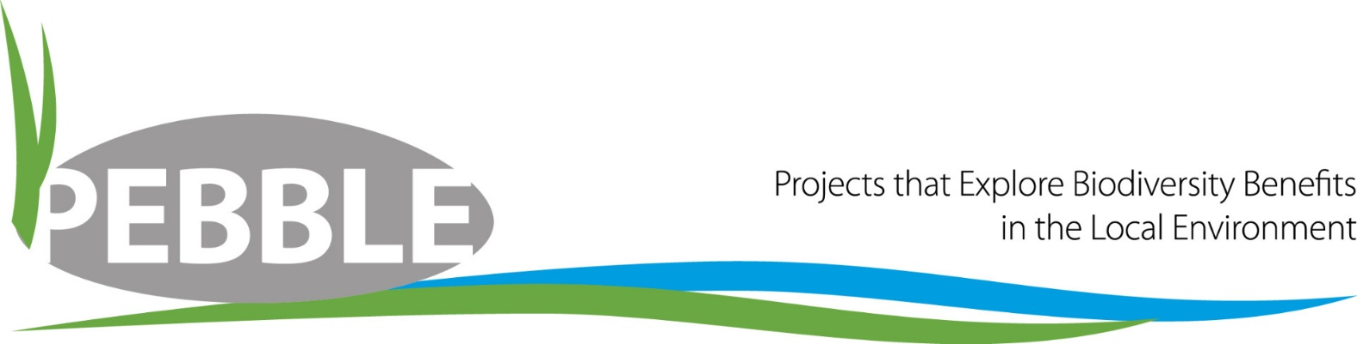
PEBBLE Application Form 2023
PEBBLE is the biodiversity improvement fund from South Staffs and Cambridge Water.
Applications for this year open on Monday 10 April 2023 and close on Monday 31 July 2023.
For more information on the scheme visit our website: South Staffs Water or Cambridge Water.
This application will take approximately 30 minutes to complete. Please send your completed application to catchment.management@south-staffs-water.co.uk, including ‘Pebble application’ and your project name in the subject line (e.g. Pebble application: Sensory garden)
* Mandatory fields

Project Basics
1. | Postcode of the project*
2. | Project address *  Please provide the address of the project. If your project area does not have a specific address, please provide the closest street name.
3. | Project name *
4. | Lead organisation *
5. | Project contact name *
6. | Contact email address *
7. | Contact postal address *
8. | Contact telephone number *

Project Details
9. | Area of improvement in hectares *
 | This is the area that will be improved by the works. If you use another unit of measurement, please include that in your answer. If you project is a linear feature e.g. hedging or river improvement, please state the width of the feature as well as the length. Please contact us if you are unsure about the area of improvement.
10. | What is the background to the project? (100 words max)  Please use this space to inform us if the site has any special designations or if there are any notable species in the area or where previously present. You can also use this space to tell us about how the project came about.
11. | How will your project improve biodiversity? * (300 words max)  Detail the improvements the funds will purchase and how they will contribute to an improvement in habitats and for which species. We do not need Latin names for species but applicants need to demonstrate they understand the species that will be attracted to the site as a result of improvements. The primary focus of the PEBBLE fund is to improve, restore or create new habitats and your answers here should reflect this. This is the main criteria that your application will be assessed on.
12. | What is the community benefit of your project? * (300 words max)  Please tell us how the community will benefit from this project. This could be a section of the community (e.g. a school) or the whole community (e.g. access to a public green space). Please tell us about any community engagement days that you hope to host or anything else that reaches out into the community.
13. | How do you intend to measure success of your project and report on this success? *  Upon completion of your project you will be required to submit a report and photos of your project. This should be submitted to us within three months of completing your project.

Funding
14. | How much funding do you require? *  During the evaluation process, one of the evaluation criteria is cost per hectare of biodiversity improvements, meaning projects delivering larger areas for less money will be scored higher. Please check our website (at the top of the application) to see how much your project may be awarded if successful.
15. | Cost breakdown *  Please give a cost breakdown for your proposed project. As this is a biodiversity fund, please be aware that there may be certain elements we are unable to fund. For a list of non-funded items, you can check the website. If you would prefer to send a spreadsheet, please email it to lucyhodge@south-staffs-water.co.uk and confirm the email address it will be sent from, in the box below.  We may not be able to evaluate your project without a cost breakdown for what you intend to do. Costs can be approximate at the moment, but this may impact your application. However, you can submit more accurate costs to us during the evaluation window.
16. | Match funding  If you have any match funding for your project, please give details.

Volunteers and Other Partners
17. | Will you be using volunteers to help deliver your project? * | Yes / No
18. | How will you work with other partners on this project? *
19. | Would you be interested in using our employees as volunteers to deliver the project? * | Yes / No
 | We have an Employee Volunteer Scheme which can support projects in our supply area. A work party date would be circulated in advance and we would try to get some employees to assist you with the project if there is enough interest. This could be anything from clearing the site, planting wildflowers or assisting with planting trees etc.
20. | Other ways we can help * | Yes / No
 | There may be other areas of our business that could offer free services to help you with your wider aims and objectives, such as our education team or our community engagement team. Would you like your details shared with the relevant teams? (This information will only be shared internally and only with those teams that may be able to help you. By selecting yes, you agree to your details being shared with those relevant teams).

Your Social Media Accounts
Please provide links to your social media channels if you have them. We will use these to tag you in our posts about your project.
21. | Facebook
22. | Twitter
23. | Instagram
24. | LinkedIn
25. | YouTube

Your Declaration
The PEBBLE fund will close on Monday 31 July 2023 and applications will be evaluated in August. Awards will be made by the 30 September. In this time, we may ask for further information about your application. Funds will be transferred between December and March, depending on when you hope to deliver the project.
If your application is successful, your project can start when you have received an outcome letter and have returned any relevant documents to us. Invoices for this work can be dated before the transfer has occurred, providing the documents we request have been returned.

26. | Photos *
 | On receipt of your application we will ask you to submit up to five photos of your project in its current state and/or photos that will demonstrate the work you hope to undertake.
 | I agree to submit photos | Yes / No
27. | What is your estimated start date? *
 | Your project can start no earlier than 1 October 2022. If you are successful in your application, we will ask you to submit a project delivery timeline and we will not be able to release the funds until you have us this.
28. | What is your estimated completion date? *
 | Your project needs to be completed by 31 March 2024. Please input date (dd/mm/yy)
29. | Terms and conditions *
Our PEBBLE fund is a competitive fund. By agreeing to the terms and conditions, this does not guarantee you the funding. A copy of the terms and conditions will be sent to you again if you are successful in your application. If you are successful in your application, but decide you no longer agree to the terms and conditions, you may withdraw your application, providing delivery has not started. If the funds have been transferred and you wish to withdraw the application, you will need to return the funds to us.

Full terms and conditions can be accessed here.

We are committed to protecting and respecting your privacy, and we’ll only use your details to administer your PEBBLE application. For more information about how we protect your privacy, please read our Privacy Policy.

 | I have read and agree to the terms and conditions: | Yes / No

